Thursday Renju Class in 5lin.

- 教育訓練組 對 ○助教
Opening i11.

Apr 13 23:16
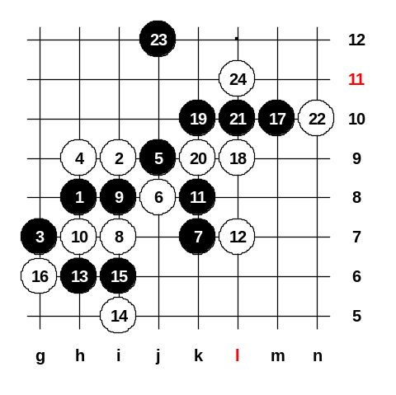
This time we will study another strong 10th move, 10-h7. Even it is very passive move, it is very powerful as a defense move. Usually, books maybe don’t mention how to play after this 10th move. But if you take a look at another sequence: 6-i7, 7-i8, 8-h7, then the book says 9-k8, 10-j8, 11-k7. That means, if in this diagram I will play 11-k8 then I will get same position as books teaches us. According to the Japanese analysis, 12-L7 is the strongest defense. The 13-h6, 14-i5, 15-i6. If white makes a move in the right side now, black will win on the left side. The 16-h5 is very bad, because black easily wins with k9, k10, L9. The strongest 16th is 16-g6. Now comes the key move for attack, 17-m10 !! In 1991, Kawamura (9dan) played 17-k10 against me and he failed black attack. Move 17-m10 is the only way to win! If 18-k10 then 19-L9 and 21-m9 and easy win. Therefore white must play 18-L9. Please remember this black stones pattern in upper side. It very often happens that you get similar kind of pattern in many of your games. So, when you have a diagonal four to play L11 and horizontal four to play to J10, in those cases, the connective stone is always J12, remember it.
In this pattern, black possible threats are:
1) m9, m12.
2) j10, j13, L11.
White can only defend them from either L11 or m12. 24-L11 is stronger than m12 of course. So, please remember this kind of pattern, next time you will self find the j12 style move. Now comes your homework. Please find the next black move (25th) that gives black win. Please write your answers to the game discussion. Next week we will take a look at your answers and then continue with other 6th move. Do you have any questions?

北極熊Andy : Apr 13 23:19
^^12i嗎我猜的~好像又不是

Apr 20 23:36
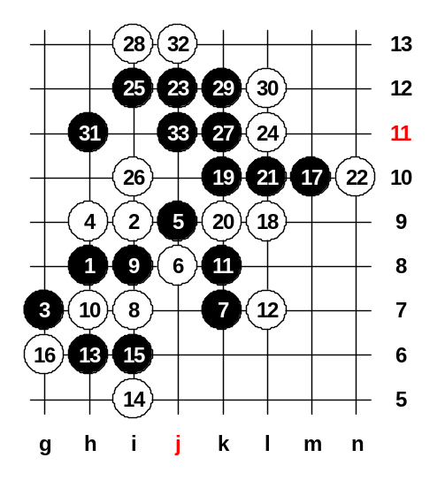
We can begin! We will look at your homework answers. The 25-i12, most people found the right first move ^^ It is very strong move, and black has a good space for attack. Assistant is right, he put the strongest white defense move, 26-i10. Now, please tell me, how black must win here. OK, I put 27-k11 as you say. White of course i13, and next black move? The 27-j13 is also interesting move. We have two choices here, 32-j13 or 32-k14. Ok, you have problems in finding win, I give you a hint. The 33-j11 is very simple win. Although the move is inside the pattern and looks bad, it is the only way to win. Now after 34-h10 black has VCF. We close this board, and open other board to study 32-k14.

純屬意外 : Apr 20 23:00
32-k14, 33-g11, 34-h12, 35-i11, g9,38-g8, h10, 41-e11, f10, e9, 46-f8, 47-c7,49-e8 (vcf) win. Maybe good.

教育訓練組 : Apr 20 23:44
To 純屬意外:
Why white need play 38-g8? No need. I cannot see black win if white does not play 38-g8.

Apr 20 23:35
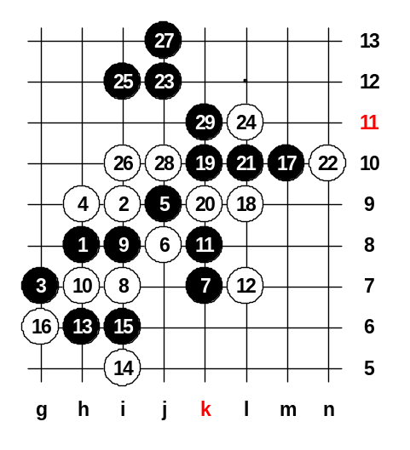
I am waiting your ideas, students ^_^ How black wins? Ok, we test 33-g11 as fivestar says. White must choose either g12 or h12. If no win, you have to move back and try other moves. ^_^ Hmm... not easy to win. We can move back to 27 and try assistant's way 27-j13. Congratulations, assistant's idea 27-j13 is right way to win! ^__^ Any other 28th move loses fast too. Ok, we close the board now. ^^ Now, we have completed the study about 6-j8, we can learn another 6th move now.

Apr 20 23:28
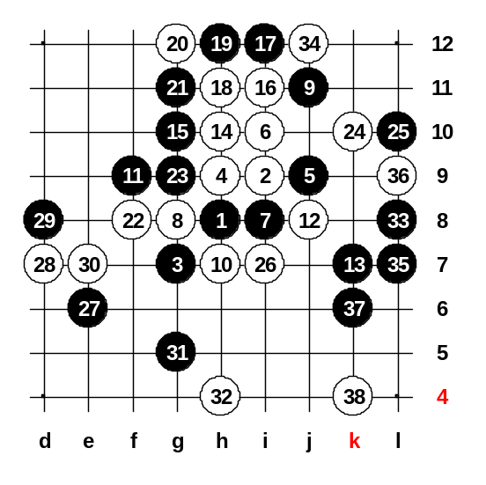
Which 6th move you want? OK, we learn 6-i10 as you wish! ^_^ Here is only one possible 7th move, i8. Any other 7th move will lose. Here the white can be active for some time, but finally when white activity is over, black will be powerful. The 8-g8, 9-j11, 10-h7, 11-f9, 12-j8. Until now, both sides made their best moves. If white will try any other move, black can have powerful advantage too soon. This pattern will turn into positional game where black can develop the attack all around the board. According to the old Japanese theory, black should play 13-g11 now. But black attack there is not easy and may often fail. Kozhin (Russia) played this pattern as white against Ants Soosyrv (Estonia) in the last World Championship. Kozhin hoped that Ants will play 13-g11, maybe Kozhin had prepared some traps there. But Ants decided to ignore the theory and change into peaceful positional style with 13-k7. Kozhin got confused and began active play as white. The 14-h10. Ants was very calm and defended that silly white attack, and very soon white activity had failed. Assistant and I will play the moves as it was played in the game between Ants and Kozhin in the World Championship. Black is surrounding white stones. By the 22nd move white activity had failed and now white has to go to defense. Ants continued calm positional style, 25-L10. White is in trouble, he has to defend both left side and lower/right side, but too hard. Kozhin chose 26-i7. The 27-e6 is a typical move in positional style game. The 31-g5 is very similar style as 27-e6. Black closes a white's line and grabs some space in lower area. Black idea becomes obvious, he tries to connect his attack with the right and upper side. Look at the position after 33rd move. All white power is dead, black has lots of power all over the board, this is very typical for this 6th move style - black gets strong positional attack. Now, black is nearly connecting the right and upper side. So, Kozhin tried the last white hope 34j12, but already too late, Ants knew how to win. Ants winning idea is easy, he will collect some black stones into the space and that power is enough for win. Kozhin played 38-k4. Ants won very quickly after that. How did black win? Ha, this is your homework. Please post your answer to game discussions. Thank you all for coming to class, see you next week! ^__^

奕學 : Apr 23 14:57
39-j6：
(A)40-i5：41-m8(3), 43-m7(3), 45-m9(43)
(B)40-m9：41-i6：
1.42-L6：43-g6(4), 45-h5. Double threat.
2.42-h6：43-m7, Black vcf. m6, k8, k9.

Apr 27 23:30
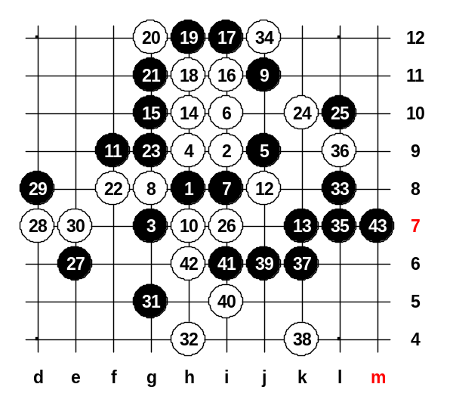
Welcome to the renju class! The last week homework position has been set up. There was only one person who discussed this homework, why others didn't find win? Homework study is very useful for developing analytical skill. Ok, show me the steps now. The J6, good. Did anyone of you find any other way? Ants also used J6 in his game against Kozhin. The m9. Now, where is next black move? 奕學says 41-i6, lets try it. Yes, now black has VCF. If 42-L6 then how black wins? 奕學 says g6, h5 is double threat. Very good. He uses the connection at d9 to have another VCF. If 40-i5 then the win is exactly the same, right? Let’s close this board and begin to study another 6th move. We have already learned 6-j8 and 6-i10. Which 6th move do you want to learn today?

Apr 27 23:15
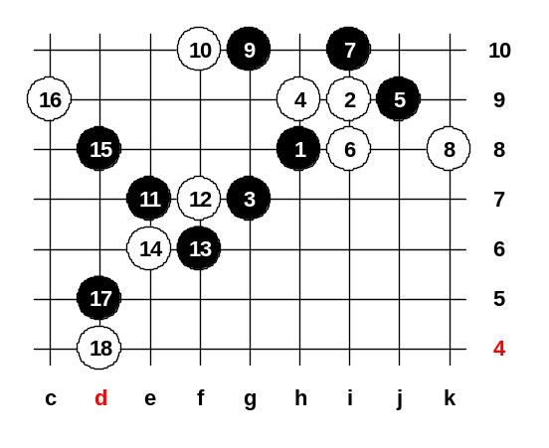
I suggest, the most important are 6-i8 and 6-i7. I can see you chose 6-i8. Indeed, it is more useful for you to learn. There are two kind of choices for black - 7-i7 or 7-i10. Move 7-i7 is more aggressive and active, whereas 7-i10 is more peaceful and positional style. Japanese players always study about 7-i7 and they seldom play i10. But if you don't want to memorize too much theory, you can learn 7-i10. I will only teach you one of the choices here, because we have short time. So you please choose. Yes, fivestar is right - 7-i7 will become d7 opening. And d7 is very difficult opening. So, please choose, i7 or i10? OK, we study 7-i10. The 8-k8.
Since white blocked the right connection channel, so the black will try to use the left connection channel. Connecting upper and the left side through the g10 stone. The best white move is 10-f10. It stops the black horizontal pair and it also stops the diagonal line g9_h8_i7. Here, it is not easy to find the best black move. If you don't know the right move, you may easily fail the black attack here. Can anyone of you guess the right 11th move? ^_^ Fivestar says f9, indeed i have ever tried f9 too in games, but it is not good because of 12-e8, I cannot find black win after that. After 11-f9, 12-e8 white has net defense pattern (see stones e8, f10, h9).
If 11-e8 then 12-f9 and black has no power. If 11-f8 then 12-e9. The right 11th move is...e7 !! It is far enough to give some good space for black, and it is yet close enough to make sure that white cannot counter-attack on the other side. If white makes any active move now in upper or right side, then black wins immediately. Black next move idea is obvious - black wants to play to f7 and then maybe f6 or any other power move near that area. White's only chance is to protect the f7 point, so white must play 12-f7. After 13-f6 black has very good position! White's best move now is 14-e6, other moves lose fast. Here black controls the whole space now, win is coming closer. 16-c9. Now, after 17-d5, black has two threats: one is VCF e5 and g5, another is d7, e8, g8. Yes, d4 is the only move that stops both threats. How will black win now? This is your homework. ^^ Please post your answers to game discussion. Ok, say your questions please. If 16-g5 then g8,e8,f9,e10 and VCF. If 8-g9 then 9-j7.

漫步荒原 : Apr 28 22:36
19-f8
.20-g9, 21-e9, 22-d10, 23-e8, 25-d7, 27-e5.
If 22-h6, 23-e8, 25-d7, vcf in c8, d9, e10.
2.20-g8, 21-d6, 22-c5, 23-h6, 24-e9, 25-f9, 27-j8.
If 22-g9 black in e5 4x3.
3.20-e8, 21-d6, 22-g9, 23-e9 black vcf in c7.

漫步荒原 : Apr 28 22:39
I think 19-g9 21-f8. If 22-d6 then 23-j8, if 22-h10 then 23-d5, 25-d7, 27-e8.

奕學 : Apr 29 23:55
If 22-d6, 23-h6, 25-j8 may be more clear.
If 22-h10: 23-h6(3), 25-g5(4), 27-i7(3) win!
(A)28-f4, j8, j6.
(B)28-j8(3), black vcf. d6, f4, j6, g6, g3.

漫步荒原 : May 2 18:49
sorry ???.. If 22-h10 then "23-d5", 25-d7, 27-e8.
23-d6??
1.28-f9, 29-e9, 31-b8, 33-c7, 35-b6, 37-b7.
2.28-c6, 29-e9, 31-h11, 33-g12, 35-e11, 37-g11.
3.28-h11, 29-b8, 31-c7, 33-c6, 35-b5, 37-b7.

May 4 23:21
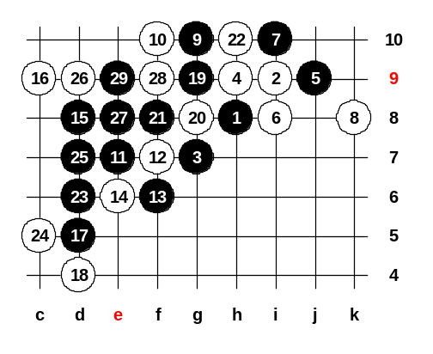
We can begin ^^ Welcome everybody to study i11 opening today! As usually, the first thing we look the last week homework answers. :) OK, position has been set up and now please tell me your answers. Where I should play the black moves to win? OK, somebody says 19-g9, shall we try it? The 20-g8. Yes, after 22-h10 white lose, as 漫步荒原 shows us. So, we will open new board and test other 22nd move too.

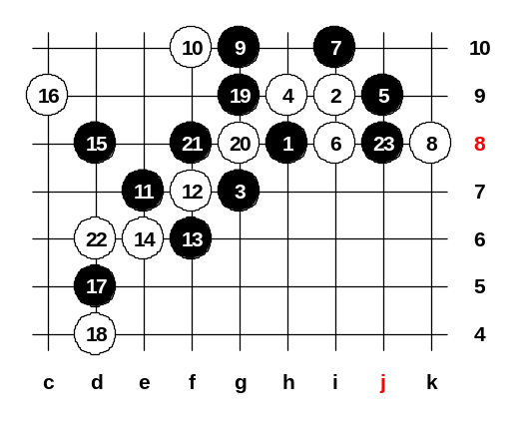
May 4 23:19
OK, and then 23 is.. ? Yes, fivestar is right, 23-j8 is the correct move! Now black has double threat to win, no way to defense. Is there anyone of you who don't understand how black wins here? Seems everybody understands. ^^ So we will close this homework board, and begin to learn another 6th move. 6-i7.

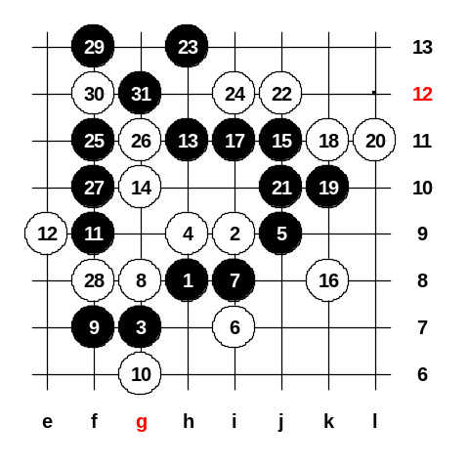
May 4 23:24
The 6-i7 is the last 6th move that we will study in this 5th move, next time we will begin to study another 5th move. Black obvious move after such 6th move is 7-i8 of course. Here, some of the 8th move will lead into the patterns that we have already studied before with other 6th moves. For example: if 8-j8 then 9-k7 and you can recognize the pattern that comes from 6-j8. If 8-h7 then 9-k8, 10-j8, 11-k7 and you will recognize the pattern again that comes from 6-j8. As we have studied those patterns before, so we don't need to repeat same moves now. However, here is one 8th move that doesn't lead to the previously studied patterns. It is 8-g8. I have checked many renju openings books about this 8th move but the books don't tell us clear answers. But when I look at the database of old games, I can see that 9-f7 is the most often played move and most successful for black. Here are so many different 10th moves possible. Which one you want to test first? OK, we will study 10-g6 first, as you wish. ^^ Hmm... so many style is possible here. But it is not easy to show simple style, almost every style will become positional game with black strong advantage. According to the Russian renju book, black should play 9-i10, but I am not sure that 9-i10 is better than 9-f7. We can test some example of positional style here. Let’s move 11-f9. The black idea is to connect the left and right side. Please you can select the 12th move. OK, you play e9, let me think. ^^ Ok, your turn now. You see, black used stones at h11 and j11 to connect the left and right sides. This kind of positional style is very powerful for black.

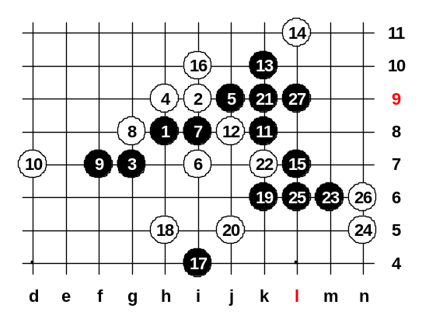
May 4 23:23
We play the same first moves, and then you can choose another defense. Do you want to try another 10th move? This time you chose 10-d7. So I play 11-k8. As usually, I will try to connect the left and right side here. Please, make your 12th move. ^^ Black wins. So we can close this diagram now. I will give you homework. In the homework pattern, we put 10-h7.

May 4 23:17
Can you guess the 11th move? Yes yes, f9, easy style, no tricks. ^^ Then 12-f8.
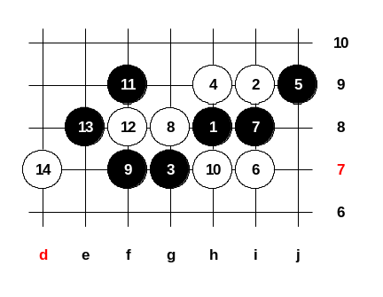
The 13th move is where? The 13-e8 is right. If 13-d9 then 14-e8 and black becomes weak. OK, I see you already set the 14th to d7. And this is your homework study pattern, please fins the way how to develop the win here. It may need some positional moves. If you find your idea of win, please write it to game discussion, thank you! Do you have any questions? ^^

奕學 : May 10 22:54
The 15-h11, I guess. then try to connect left and right sides.

May 11 23:18
At first, we will take a look at last week homework. Ok, where are your answers? It is very useful homework, you can learn positional style from this homework, how to play softly. Yes, h11 seems very good, and it is correct. Now, white has several defense moves, but 16-i10 seems to be the strongest. How about 17th move? OK, we try 17-j11. The 18-i12. The 19-i11, 20-g11. And then? Now, how black plays next move? Haha, yes, move 17 is wrong, it is good that you realized that. ^_^ Let’s move back, you can try another 17th. OK, you say 17-i12, lets try. 19-j11. It seems white has only one good move here, 20-j10. Please you tell me the black steps ^^ OK, we put 21-k10. The 22nd must to L9. And then? Please everybody think carefully and try to find black win now. OK, we put 23-d9 first. 24-c10. Now, L11 and i11?
OK, 29-e9 as you say. The 30-g9 seems the best. Yes, black wins now, very good ^^
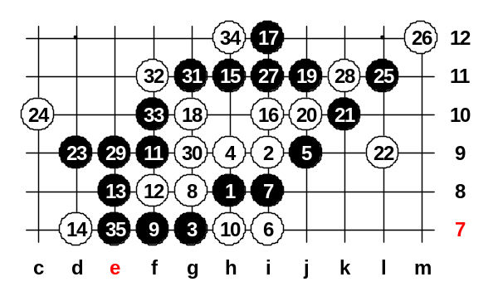
This was a very useful homework, you learned how to study the positional style steps h11, i12, j11. You learned that sometimes it is necessary to play a four (i12) first before moving to j11. If black doesn't use the four to i12 then white can self take the i12 point and black has no win. Such situation may happen in many other similar games. We can now, take a look at another 5th move, 5-g9. It is the most often used 5th move in this opening.

